MWIS HOSTS BIDDING AND ESTIMATING TRAINING ACADEMY
FOR SMALL CONTRACTORS IN CITY OF LA

Merriwether & Williams Insurance Services (MWIS), a Hub International company, hosted a five-week “Construction Bidding & Estimating Training Academy” designed to help small and local contractors develop and improve their estimating skills when bidding on public works projects with the City of Los Angeles. The academy, which ran from February 17 through March 17, is part of the Los Angeles Regional Contractor Development and Bonding Program (CDABP), which MWIS administers for the City of Los Angeles and LA Metro.

The training program featured a range of expert speakers from the City of Los Angeles and notable construction companies such as Kiewit Corporation, Clark Construction, Whiting-Turner Contracting Company, and Pinner Construction Company. The speakers presented on various topics surrounding bidding and estimating, sharing their industry insights, experiences, and knowledge of best practices to attendees, 14 of whom graduated and received certificates of completion.

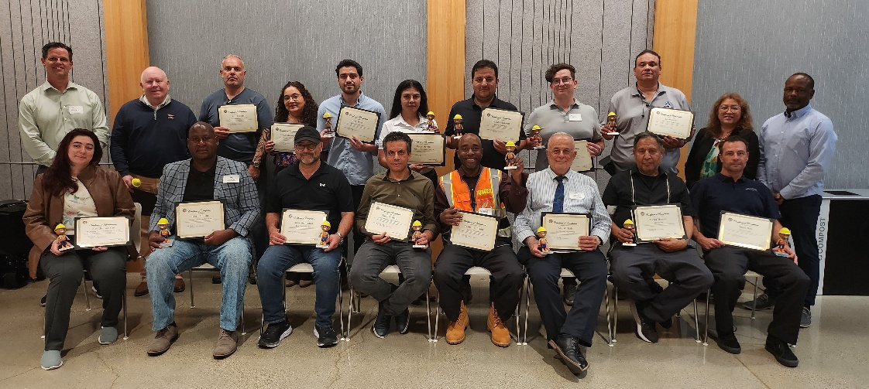
Academy participants show their graduation certificates,
while joined by program officials.

Combining in-person and virtual training sessions with a practical, project-based approach, the academy showed real value to contractors aiming to grow their skills, network with peers, and stay current on industry trends.

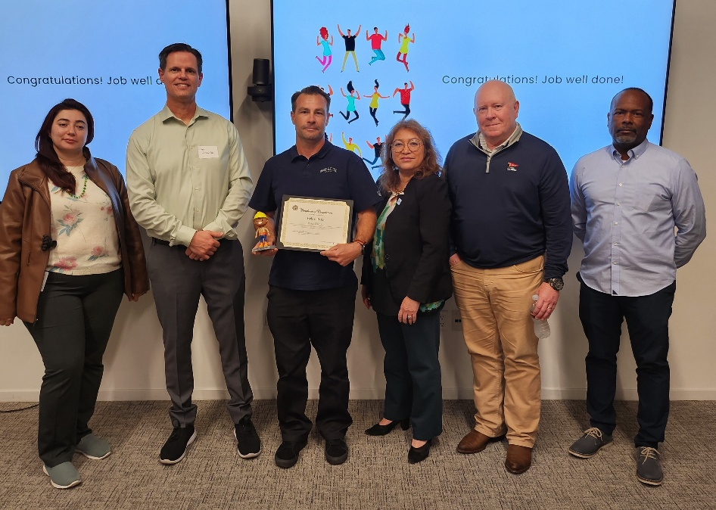
"The presenters and the course were great. They opened
my eyes to how the contracts work and how they structure
their estimates,” said Brian Bois, owner and CEO of Image
Electric, shown with his graduation certificate.

One graduate was Brian Bois, owner and CEO of Image Electric. Mr. Bois, while reflecting on his experience in the program said, "The presenters and the course were great. They opened my eyes to how the contracts work and how they structure their estimates. It was all very new to me, including how public works operates and puts their bids together. The class was well organized; they handled everything nicely with the meetings, shared files, and so on.”

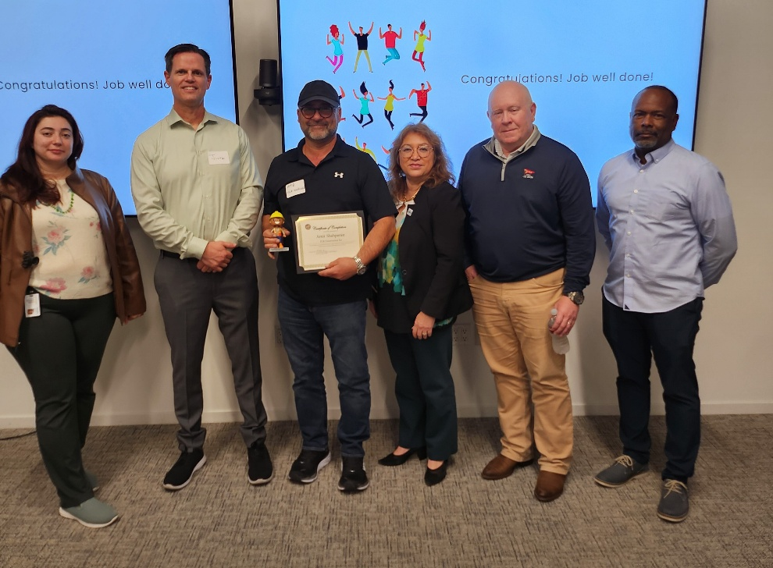
“The training, the material, and everything was helpful
and very trustworthy for me,” said Wahid Sabawoon,
owner and CEO of Daynight Power Inc., shown with his
graduation certificate.

Another graduate was Wahid Sabawoon, owner and CEO of Daynight Power Inc.
Mr. Hayles had this to say about his experience in the Academy: “One of my friends referred your academy to me, and, after that, I registered for a training. I came to your academy, and I was very happy. The training, the material, and everything was helpful and very trustworthy for me. I use the material you gave us regularly. I've come to understand a lot through it, and it's been helpful for both me and my company.”

The academy generally received positive participation and feedback from the companies that attended. Contractors gained valuable knowledge and built new connections by networking with other small and diverse construction firms. This networking opened the door to potential partnerships. Participants recognized that the knowledge they gained from investing their time and effort in the academy would help grow their businesses, build capacity, and strengthen their ability to take advantage of public works opportunities.

For more information on the Los Angeles Regional CDABP and future training sessions, visit our website at LAConDev.com.

