mwis co-hosts webinar on “navigating disabled veteran construction opportunities at la metro”

On July 29, Merriwether & Williams Insurance Services (MWIS), a Hub International company, co-hosted with LA Metro a webinar entitled, “Navigating Disabled Veteran Construction Opportunities at LA Metro.” Veteran entrepreneurs learned how to become contract-ready, strengthen bonding capacity, secure financing, and pursue opportunities with LA Metro and other public agencies.

The event was designed to connect disabled veteran business enterprises (DVBE) with the tools, relationships, and resources needed to compete successfully for public contracting opportunities.

Participants learned about LA Metro’s Contractor Development and Bonding Program’s (CDBP’s) four primary areas of support:

- Customized business assessments and technical-assistance plans
- Bonding, contract financing, and project support
- Workshops, coaching, and contractor education
- Networking with prime contractors, public agencies, and industry partners

Businesses enrolled in the program receive access to a dedicated contractor development manager, assistance developing a contractor profile, referrals to bid opportunities, bid-document and contract reviews, bonding support, project monitoring and training in areas such as bidding, estimating, contract management, and OSHA requirements. CDBP services are provided at no cost to contractors.

Jan Davis, a Strategic Business and Construction Career Representative with LA Metro, explained that the agency maintains a 3% DVBE participation goal. She also walked attendees through LA Metro’s vendor portal, open solicitations, 12-month contracting forecast, and calendar of networking events.

Ms. Davis encouraged businesses to attend pre-bid meetings, request bidders and plan holders lists, monitor solicitations regularly, and subscribe to LA Metro’s contracting updates.

“Networking is key when you are building relationships with prime contractors,” Ms. Davis said. “Even if you are not part of an initial team, making yourself known may position your business for later work packages and future opportunities.”

The webinar featured program participant Cristian Trujillo, a U.S. Air Force reservist and founder of Golden Scaffold. Mr. Trujillo enrolled in the CDBP in 2024 and participated in its Bidding and Estimating Training Academy in 2025. Since joining the program, Golden Scaffold has secured several contracts. Mr. Trujillo credited certifications, networking, consistent follow-up, and the program’s contract-review assistance with helping his company compete.

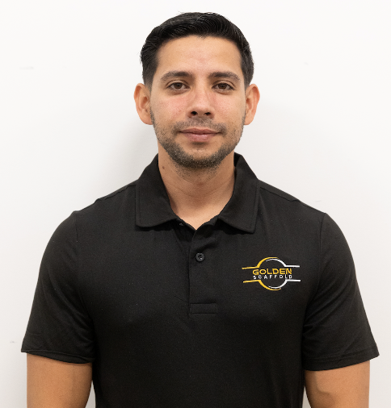

“If you haven’t enrolled, I 100% recommend it.”

-- Mr. Cristian Trujillo, founder of Golden Scaffold
and a U.S. Air Force reservist.

“If you haven’t enrolled, I 100% recommend it,” Mr. Trujillo said. “Following up is huge. Attending networking events and staying connected helped me meet the general contractor that ultimately hired my company.”

Program participant Muhammad Hussein of Versal Consulting also discussed the importance of addressing bonding and certification requirements early. He encouraged contractors to contact the program before bidding on larger projects, so they understand the required documentation, financing, and approval timelines.

Gene Hale, CDBP program advisor and CEO of G&C Equipment Corporation, encouraged veteran business owners to market themselves directly to the estimators developing bids for prime contractors. “You still have to go out and meet people,” Mr. Hale said. “Getting in front of the right person, presenting your credentials and building those personal relationships remain extremely important.”

The webinar also featured Aimee Bravo, director of the Los Angeles Veterans Collaborative, who shared resources available to veterans and military families throughout Los Angeles County. The Collaborative helps veterans navigate benefits, community programs, policy changes, emergency assistance, and other services through its countywide network and weekly newsletter.

Eligible contractors are encouraged to enroll in the LA Metro Contractor Development and Bonding Program before pursuing opportunities requiring bonding or contract financing. Businesses should also ensure that all applicable LA Metro, state and local certifications remain current. To learn more about the CDBP, visit https://www.lacondev.com/

