MWIS HOSTS CONTRACTING OPPORTUNITIES WORKSHOP
WITH LA CITY COUNCILMEMBER CURREN PRICE

On May 21, Los Angeles City Councilmember Curren D. Price, Jr., co-hosted an engaging “Navigating LA City Contracting Opportunities” in-person workshop with Merriwether & Williams Insurance Services (MWIS). The purpose of the workshop was to raise awareness about the diverse opportunities available through the City of Los Angeles departments for small and minority contractors within Council District 9. The workshop was a component of the LA Regional Contractor Development and Bonding Program (CDABP), which MWIS, a Hub International company, administers for the City of LA and LA Metro.

The event started with a warm welcome from Councilmember Price, who encouraged attendees to "get involved, engaged, and get resources," highlighting the supportive role of the CDABP in fostering business growth.

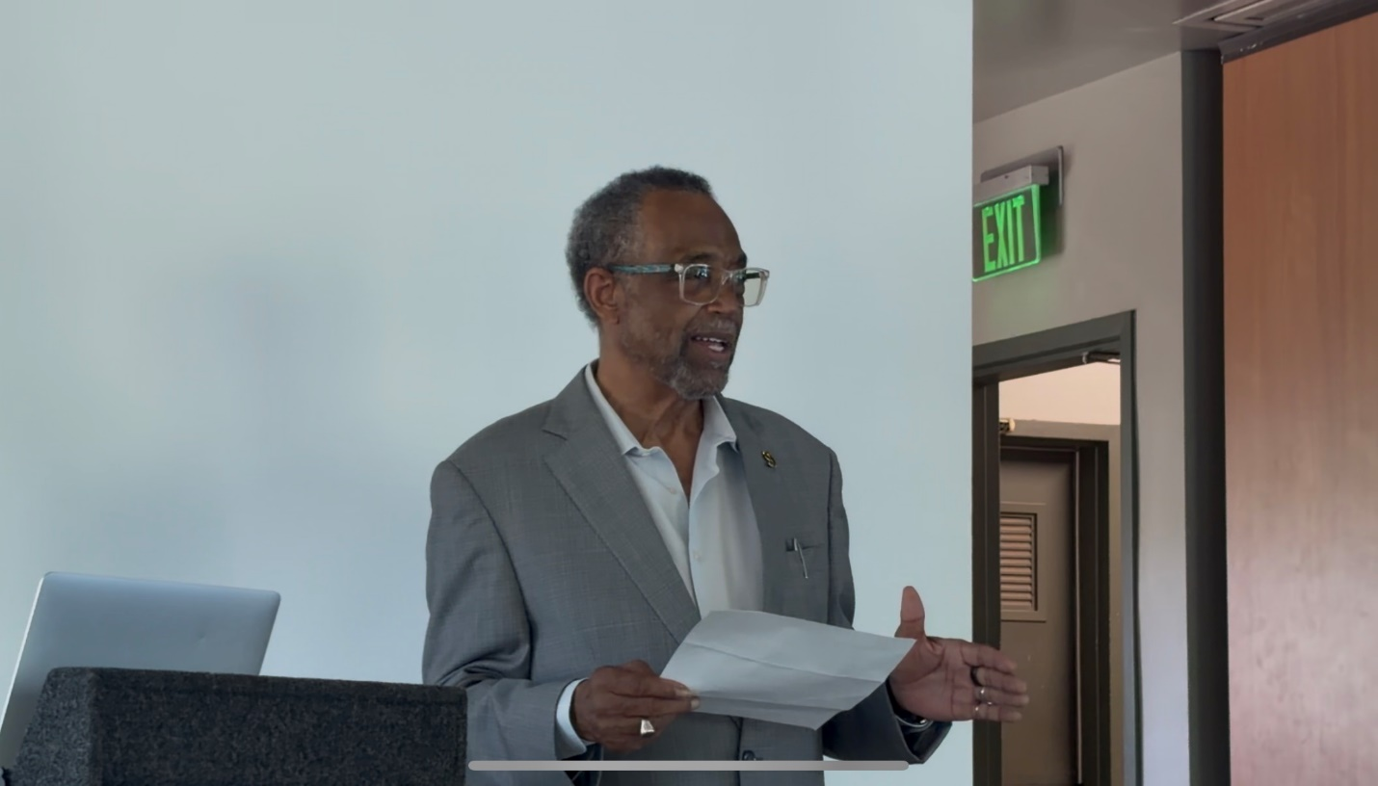

“Get involved, engaged, and get resources.”

-- Curren D. Price, Jr., LA City Councilmember

The event was attended by representatives from Los Angeles World Airports (LAWA), Port of Los Angeles (POLA), Los Angeles Department of Water and Power (LADWP), and the Bureau of Contract Administration (BCA), all of whom discussed upcoming construction projects shaping the city's future and the significant economic opportunities tied to the upcoming Olympic events in 2028.

The program featured insightful presentations from the above mentioned agencies, covering essential topics such as doing business with the city, obtaining necessary certifications, and navigating the procurement process. This event served as an invaluable platform to connect small and diverse contractors with city resources and opportunities, emphasizing Los Angeles's commitment to inclusive economic development.

In addition to the in-person May 21 workshop, a virtual follow-up workshop was held on May 28 for contractors who could not attend the in-person event.

The CDABP thanks Councilmember Price, the speakers, and all attendees for contributing to the event’s success. The program reaffirmed its commitment to creating accessible opportunities for contractors and transforming individuals and communities through its initiatives. Its primary goal remains to ensure that small and local contractors have the necessary resources and tools to compete successfully in the marketplace. The CDABP team stands ready to assist contractors at every stage of the contracting process, from bonding to project completion.

For more detailed information about the program and upcoming opportunities, please visit the CDABP website: www.LAConDev.com

