MWIS HOSTS “MASTERING YOUR JOB START UP
IN THE CONSTRUCTION INDUSTRY” WORKSHOP

On August 4-5, Merriwether & Williams Insurance Services (MWIS), a HUB International company, hosted a two-day in-person training entitled, “Mastering Your Job Start Up in the Construction Industry.”

Led by Robert Lowery, Field Support Project Executive at MWIS, the sessions equipped contractors with the skills, knowledge, and confidence to successfully launch construction projects. Mr. Lowery said, “True mastery of job start up demands more than technical know-how. It takes hands-on experience and the ability to communicate effectively.”

Throughout the two days, participants dove into a broad range of essential topics: preliminary notices, change orders, injury and illness prevention programs, safety protocols, job hazard analysis, site visits, payment processes, requests for information, and other key considerations when kicking off a project.

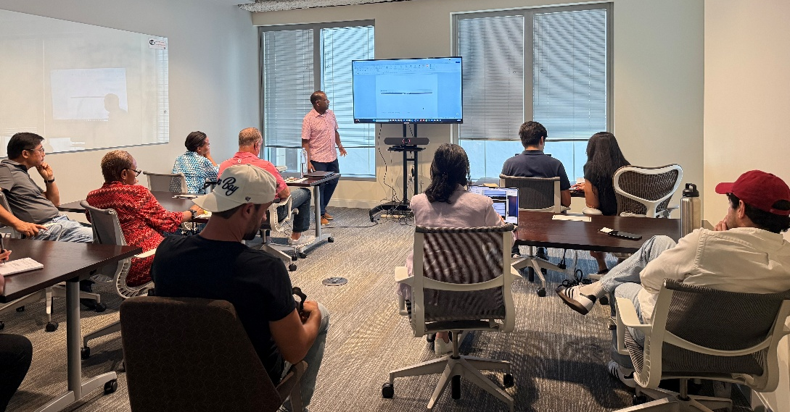

“True mastery of job start up demands more than
technical know-how. It takes hands-on experience
and the ability to communicate effectively.”

-- Robert Lowery, Field Support Project Executive,
MWIS, shown leading the class

The session underscored the importance of an organized and transparent approach when taking on new projects. Angeline Longshore from We Clean Windows LA, LLC stated, "It was a lot more detailed and informative than I had expected. For a newbie like me, it was still really informative. The way he broke it down, explained everything, and allowed us to ask questions, and never made it feel like a dumb question, and answered it so that I understood, was incredible, amazing. I know that there's so much more, and the resources are incredible. I feel like I have a home to come to, in a sense, where I feel supported. And it really is an incredible feeling to feel supported, especially coming from Hawaii, coming to a new city, and knowing that this is here and free. It is really this wonderful support that I so appreciate."

Contractors not only acquired valuable knowledge but also built meaningful connections through networking with other small and diverse construction firms. Participants recognized that the lessons gained from the training would help drive business growth, expand capacity, and enhance their ability to take advantage of public works opportunities.

Candace Bailey from Jamerican Eco Hauling LLC shared, "I really enjoyed it. This has been a learning experience. The presenter was very thorough, very knowledgeable, and had a lot of patience. The big takeaway was the change order process; he reiterated the importance of that a lot, and how you are entitled when you have a contract. As a general or small general contractor, he really emphasized that, which was very, very good. So, you're not intimidated, because being a smaller contractor, you are entitled to know and have some say in a lot of things. That was definitely a takeaway. And again, he was very informative; he knows his stuff and is very seasoned."

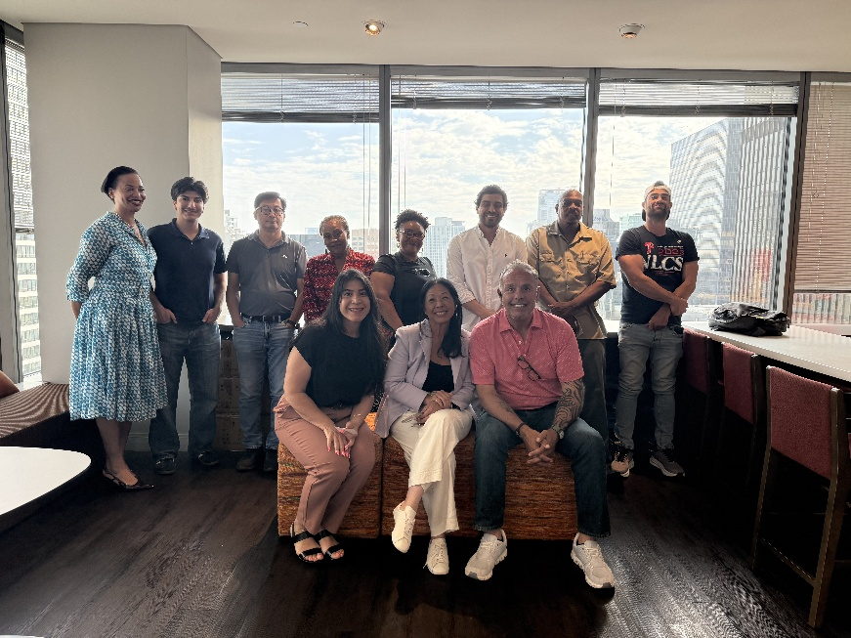

The workshop attendees pose after the class completion.
One contractor commented on the program by saying,
“I know that there's so much more, and the resources are
incredible. I feel like I have a home to come to, in a sense,
where I feel supported.”

For more information on the Los Angeles Regional Contractor Development and Bonding Program and future training sessions, visit our website at LAConDev.com.

