MWIS CO-HOSTS WEBINAR WITH LA METRO BOARD
MEMBER BARGER ON HOW TO NAVIGATE CONSTRUCTION
CONTRACTING OPPORTUNITIES

On July 8, Merriwether & Williams Insurance Services (MWIS) co-hosted, with LA County Supervisor and LA Metro Board Member Kathryn Barger, a webinar entitled, “Navigating Metro Contracting Opportunities.” The webinar was a component of the LA Regional Contractor Development and Bonding Program (CDABP), which MWIS, a Hub International company, administers for LA Metro and the City of Los Angeles.

The event aimed to empower local contractors by sharing insights into LA Metro construction contracting opportunities. Attendees had the chance to interact directly with industry experts and learn about key resources and tools essential for navigating the complexities of government contracting. The event encouraged meaningful discussions and networking, helping participants improve their skills and knowledge to succeed in securing contracts and expand their businesses in the region.

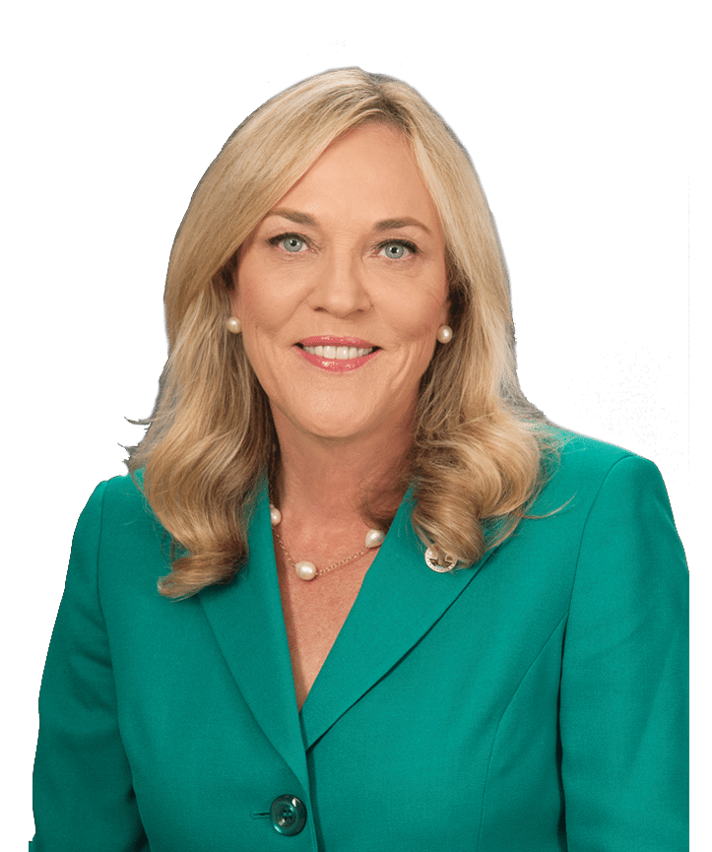

“The County has allocated millions of dollars
for public construction projects, opening
doors for contractors to take on major work.”

-- Kathyrn Barger, LA County Supervisor
and LA Metro Board Member

Supervisor Barger, who represents District 5, provided a video welcome to all attendees, highlighting the exciting prospects for contractors involved in the program. She emphasized the historic opportunities available and stated, “The County has allocated millions of dollars for public construction projects, opening doors for contractors to take on major work. Additionally, Metro is about to launch ambitious construction projects worth millions, which will significantly transform our community.” She encouraged small and diverse contractors present at the event to seize these opportunities.

Highlighting the importance of inclusivity, she explained how these contracts could benefit a wide range of businesses, especially those owned by underrepresented communities. By participating and applying, these contractors could gain valuable experience and help create a more equitable marketplace.

The LA Regional CDABP is committed to promoting the growth of small, local, and diverse contractors in Los Angeles County with LA Metro. For those interested in joining the no-cost program, visit www.LAConDev.com for more information or send an email to mwisinfo@imwis.com.com.

