MWIS HOSTS WEBINAR ON “BUSINESS, FINANCIAL REPORTING,

AND TAX TIPS FOR CONSTRUCTION FIRMS”

Strong financial management is essential for contractors looking to build sustainable businesses, improve cash flow, and position themselves for future growth.

This issue was highlighted during an August 6 workshop entitled, “Business, Financial Reporting, and Tax Tips for Construction Firms.” The webinar was led by construction industry CPA Glenn Carniello, who shared practical strategies contractors can use to better understand their financial performance and make more informed business decisions. The webinar was offered by Merriwether & Williams Insurance Services (MWIS), a Hub International company, which administers Contractor Development and Bonding Programs for various municipalities interested in assisting small and local construction contractors.

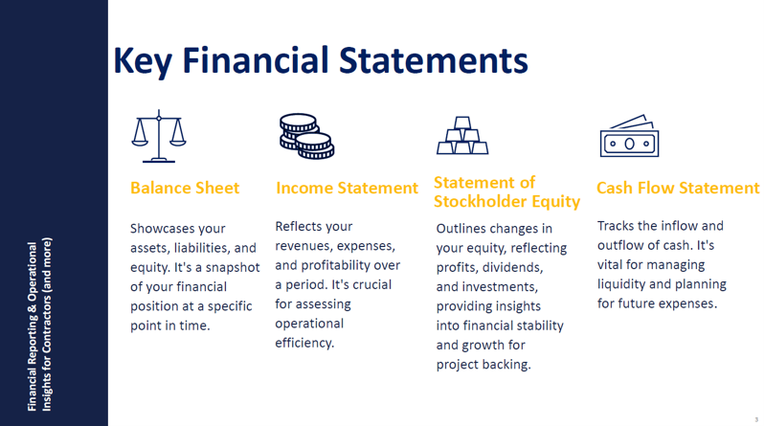
Tools for Managing a Business

One of the key themes of the workshop was the importance of accurate and timely financial reporting. Rather than viewing financial statements simply as documents required by banks, bonding companies, or accountants, Mr. Carniello encouraged contractors to use them as tools for managing their businesses. Regularly reviewing balance sheets, income statements, cash flow statements, and job-cost reports can help contractors identify trends and understand which projects, customers, and areas of their operations are generating the strongest results.

Mr. Carniello also discussed percentage-of-completion accounting, an important concept for construction businesses. Using the cost-to-cost method, contractors can compare the costs incurred on a project with the total estimated cost to determine how much of the project has been completed. This provides a clearer picture of project performance than simply looking at how much has been billed or collected.

Cash flow was another major focus. Contractors often pay employees and other project expenses well before receiving payment from customers, making strong billing practices especially important. “You want to get bills out early and often,” Mr. Carniello told participants, encouraging contractors to invoice as soon as their contracts allow rather than unnecessarily waiting until the end of a project.


“You need a good bank. You need a good bond
agent. You need a good attorney.”

-- Glenn Carniello, CPA, and webinar presenter

The session also emphasized the importance of having the right professionals supporting the business. Contractors do not have to become accounting experts themselves, but having knowledgeable CPAs, bankers, bond agents, attorneys, and other advisors who understand the construction industry can become increasingly important as a company grows. As Mr. Carniello emphasized when discussing the importance of building a strong professional team, “You need a good bank. You need a good bond agent. You need a good attorney.”

Ultimately, strong financial reporting is about more than compliance. By understanding their numbers, monitoring job costs, improving billing practices, and surrounding themselves with knowledgeable advisors, contractors can gain greater control over their businesses and make better-informed decisions as they pursue new opportunities and long-term growth.

For more information on MWIS’s Contractor Development and Bonding Programs, go online to www.imwis.com.

