MWIS HOSTS 30-HOUR OSHA TRAINING COURSE

The Occupational Safety and Health Administration (OSHA) 30-hour training course, tailored for those with safety responsibilities, is a comprehensive program designed to enhance workplace safety and health awareness.

From July 13 through July 16, Merriwether & Williams Insurance Services (MWIS), a HUB International company, hosted a OSHA 30-hour training course, which was offered as a component of the Los Angeles Regional Contractor Development and Bonding Program (CDABP). MWIS administers the CDABP on behalf of the City of Los Angeles and LA Metro.

This year's series was warmly guided by Natalie Bradford, instructor with Safety Dynamics Group, whose dedication to reducing losses that impact the work environment shone through in every session. Nine dedicated participants completed the program, earning a credential that reflects a growing industry standard and their personal commitment to fostering safe, compliant work environments.

Over the course of four days, participants received instruction in a wide range of safety topics, including an introduction to the federal OSHA, bloodborne pathogens, hazard communication, fall protection, electrical safety, emergency action planning, fire prevention and exit protocols, safety and health management, lockout–tagout procedures, materials handling, personal protective equipment, labor law compliance, workers' compensation, and the rights and responsibilities of both employees and employers.

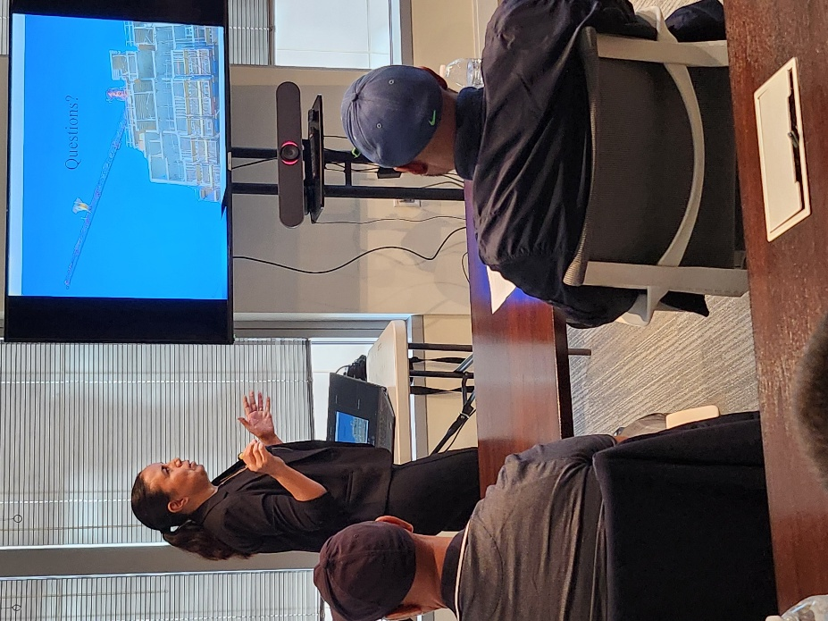

“Nurturing a proactive safety mindset doesn't just reduce
risk. It lifts morale, supports productivity, and helps people
feel genuinely good about the work they do.”

Natalie Bradford, Instructor, Safety Dynamics Group

The sessions were warm and interactive, with Ms. Bradford making space for genuine dialogue and welcoming questions from everyone in the room. She gently reminded participants that while OSHA standards are the foundation on every construction site, true excellence asks a bit more of us.

Ms. Bradford encouraged a deeper understanding of OSHA regulations, drawing thoughtful attention to hazards that often go unnoticed. She spoke to regulatory compliance, meaningful risk mitigation, and the quiet but powerful ways that safety practices shape a company's culture. Above all, she emphasized that “nurturing a proactive safety mindset doesn't just reduce risk. It lifts morale, supports productivity, and helps people feel genuinely good about the work they do.”

Mark Douglas, owner of High Note Technologies LLC, and one of this year's graduates, shared his reflections: "The experience was good. I had taken OSHA 10 previously, and it was an introductory course. I found that OSHA 30 gave me a much more in-depth and thorough understanding of safety, the things that could happen. And doing the in-person format, I think, allowed me to digest it much better, because I had done it online previously, and I just don't think the experiences equate in any particular way.”

“Getting feedback from the instructor,” Mr. Douglas continued, “feedback from members in the classroom, hearing them talk about their personal experiences on their various job sites, it's a much fuller experience than sitting at your desktop or on your phone answering questions and watching videos. So overall it was a very good experience. It allowed us to benefit from the experience of our peers and other students, as well as the instructor. I would definitely choose that format, and the instructor was very professional, very good on their subject matter. So overall, it was a very good experience.”

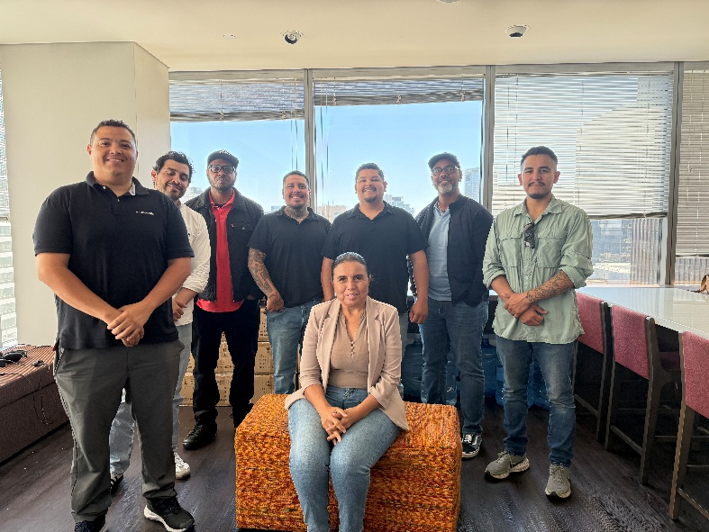

Instructor Natalie Bradford, seated,
poses with graduates of the course.

For more information on the Los Angeles Regional Contractor Development and Bonding Program and future training sessions, visit our website at LAConDev.com.

