MWIS CO-HOSTS WEBINAR ON “PRACTICES FOR
PROGRESS IN SMALL BUSINESS INCLUSION”

On July 9, Merriwether & Williams Insurance Services (MWIS), a Hub International company, joined with BBC Research and Consulting for a webinar entitled, "Practices for Progress in Small Business Inclusion,” which was the second installment of a three-part "Policies, Practices, and Programs" webinar series.

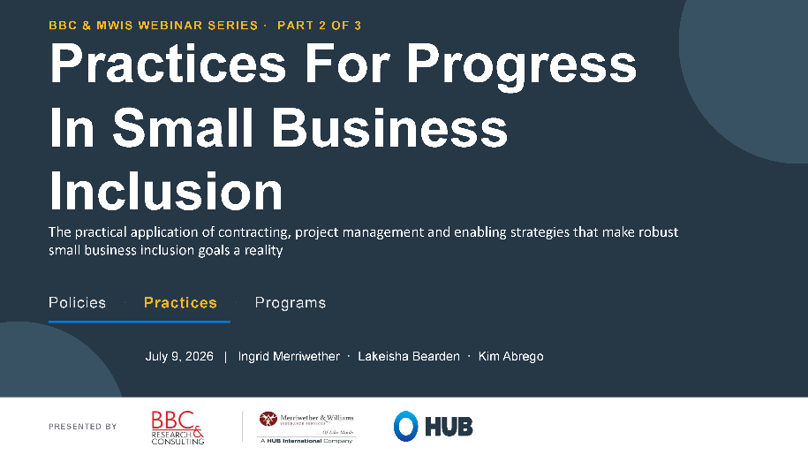

Ingrid Merriwether, President of Aligned Risk Management at MWIS, opened the session by saying, “Our program loss ratio is less than one-tenth of 1%. The industry loss ratio in surety bonding is about 24%." Merriwether explained that this finding "demonstrates the true capacity of small firms, despite perceptions that they're higher risk or they lack adequate capacity to perform in a substantive way in public works. We've seen quite the contrary."

Ms. Merriwether also said, "What we have witnessed is that when you address the systemic barriers, provide technical support, apply good risk management principles, not only can they successfully participate and win work, but they successfully complete work without defaults with a much greater level of success than the industry as a whole."

On the obstacles agencies face, she said, "We understand the limitations around compliance, legal covenants or restrictions. The staff resources for contract administration may make it more challenging.”

"It's never happened that an agency's told us they have too many bidders," Ms. Merriwether said. “For every small business that's hired, 58% of their contracting dollars goes back into the local economy versus 22% from large firms."

That research came from BBC Research and Consulting, whose Managing Director and CEO, Samir Bawa, said, "We've been conducting contracting equity studies for several decades now to understand outcomes that small and economically disadvantaged businesses face in government contracting."

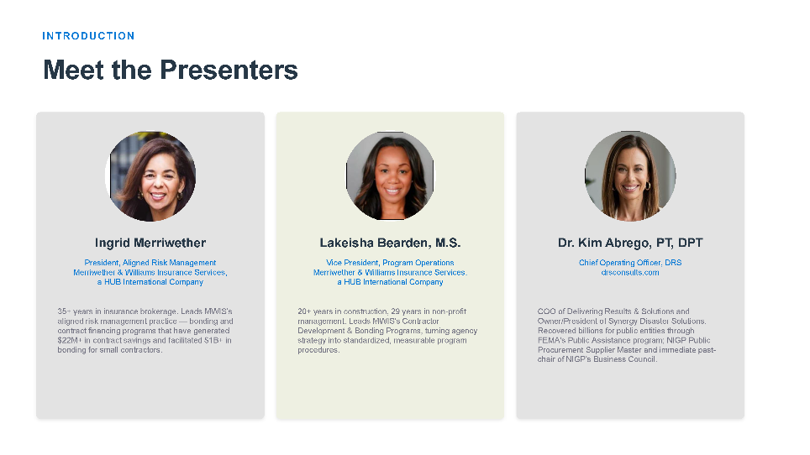

From there the conversation turned to how agencies can create direct opportunities for small firms rather than routing them through subcontracts. MWIS Vice President of Program Operations Lakeisha Bearden made the case for prime contracts over subcontracts. She said, "Whereas your subcontracting opportunity really restricts that contractor to the prime’s payment terms, net 60, net 90 ... They're hidden under the Prime’s contractor's umbrella."

"Being able to be a small business and prime really does allow you to compound your growth at a prime level," Ms. Bearden said. "Agencies can create small business prime opportunities through unbundling, best value procurement, and shelter bidding."

The session's second half shifted to what happens after a contract is signed. Here, DRS Chief Operating Officer Dr. Kim Abrego offered a reminder, "Awarded isn't the same as delivered." She argued that participation goals too often get set at the bid stage and then checked only at closeout, with little visibility into what happens in between.

Dr. Abrego made the case that construction managers are best positioned to close that gap, since they are typically the only party watching a project from award through completion. On the risk of leaving small firms without a clear point of contact, she said, "A small firm with nowhere to escalate a stuck payment can lose six figures sitting in limbo. A designated advocate with real authority unsticks it in weeks instead of quarters."

Her recommendations included monthly reporting on committed versus actual dollars, owner approval before any small business substitution, and a documented escalation process before a subcontractor is ever terminated.

Anyone interested in MWIS's Contractor Development and Bonding Programs, can visit here or send an email here. For those interested in a recording of the session visit here.

